MASCHERPA Audric ROB 3 2022 / 2023

**POLY-SNAKE**

**Weekly report n°10 from 16/01/23 :**

Following the end of year holidays, some aspects of the PolySnake have been reviewed. First of all, it was decided to change the command crate from an Nvidia card to a raseberry nano card in figure 10.1. The objective in using this map is to allow our robot to move around in its environment using a camera and a red arrow showing it the way while reducing the space required due to the size of the raseberry card much less imposing than the Nvidia card.

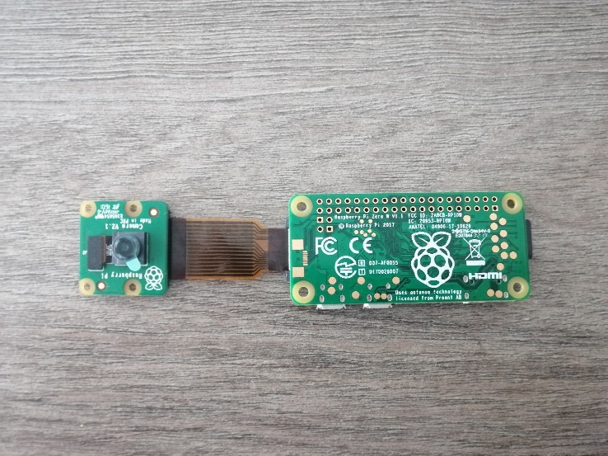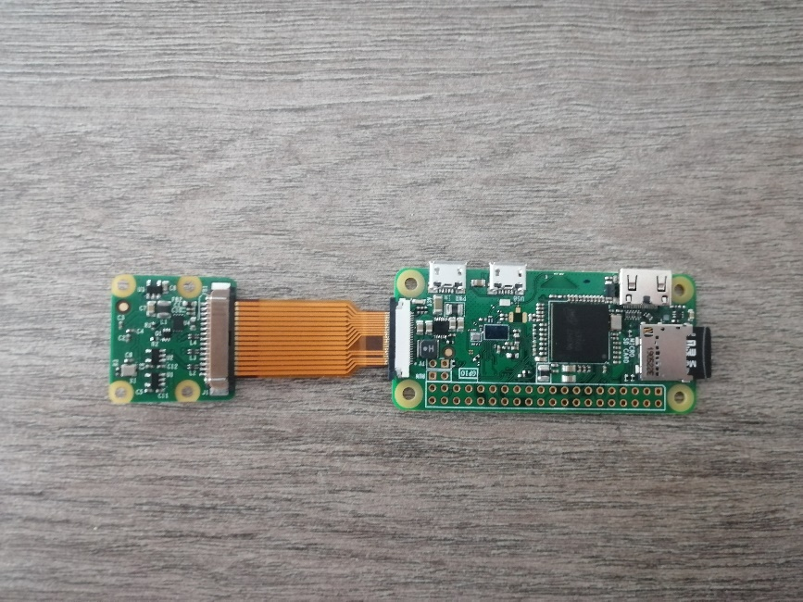

Figure 10.1

Figure 10.2

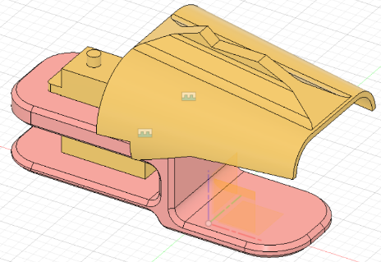Thus, the change of control card had the direct consequence of completely redoing the modeling of the head of the snake as well as the modules so that the latter are coherent in terms of size. This is why the size of the new modules have been increased in Figure 10.2 to better match the size of the head plus a new piece to give a more aesthetic appearance to the PolySnake.

To put it simply, this piece is an improvement of the old module that made up the body of the project

Similarly, a new model of the head in figure 10.3.1 and 10.3.2 has been made with an aesthetic aspect brought to the piece to make it more pleasant to look at. However, it is important to keep in

mind that this piece is not yet completely finished and that some modifications will be made to it in the future.

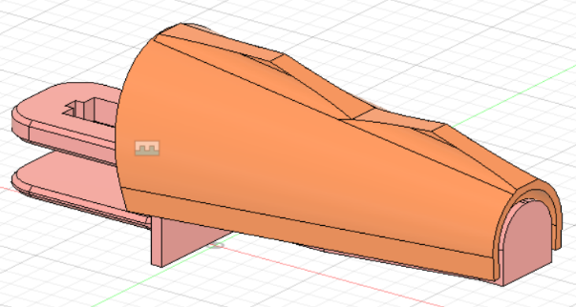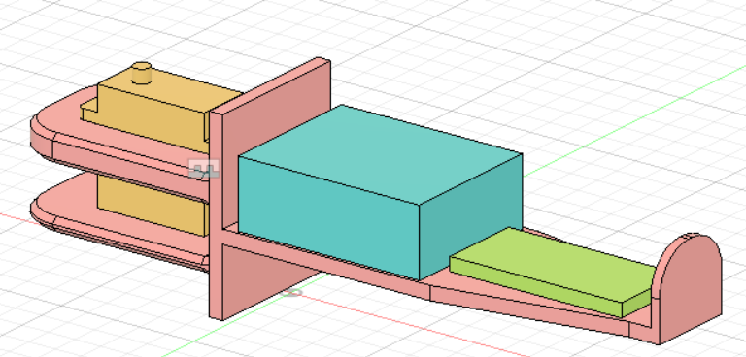

Figure 10.3.2

Figure 10.3.1

Thus we can underline in figure 10.3.2 the presence of the servomotor in yellow, the arduino card in blue and finally the raseberry nano card in green with the camera which is not represented but which will be placed on the vertical base at the end of the pink piece.

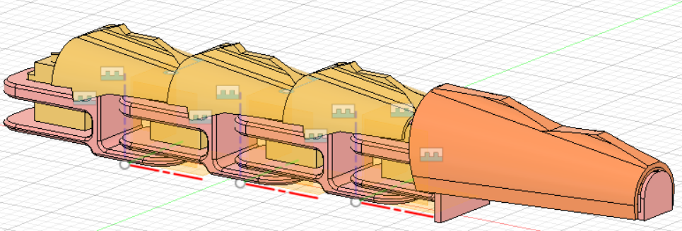We can have a glimpse of the snake as a whole in figure 10.4

Figure 10.4

And finally, the end of this session was centered on the creation of classes for the main program of the movement of the snake.

Here is a github link to the program and these classes : <https://github.com/YOUSSNDR/PolySnake/tree/main/programmes/Classes>